Challenges: BIOES annotation → spaCy NER Pipeline
🚦Instructions
You are given a CSV file containing NER annotations with BIOES-tagged tokens called ‘ner_bioes.csv’. Convert this dataset into a fully structured spaCy NER training dataset and then build a complete pre-processing pipeline.
Complete the following tasks using a Python notebook or Google Collabs, and when you have finished, send the file to my email address.
You can use Pandas, spaCy or any other Python libraries.
spaCy documentation:
https://spacy.io/usage/spacy-101
https://spacy.io/api/entityrecognizer

Task 1 — Load & Reconstruct Sentences

Objective: Convert CSV into grouped sentence structures.

Output format:
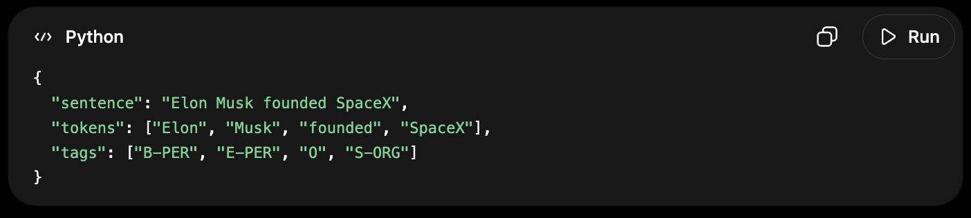

Task 2 — BIOES Validation

Objective: Check dataset consistency.

Requirements:
- Ensure correct BIOES transitions
- Detect invalid sequences (e.g., E-ORG without B-ORG)
- Print warnings and fix it.

Task 3 — Convert BIOES → Entity Spans

Objective:
Convert BIOES tagging into:
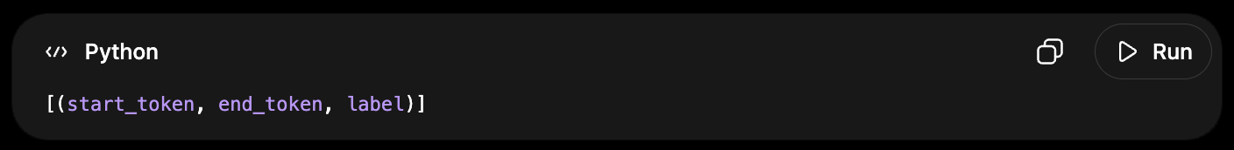
Then map to text spans.

Output:
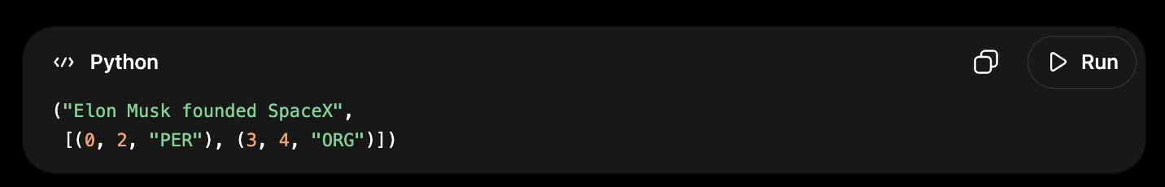

Task 4 — Convert to spaCy Format

Objective:
Build training dataset:
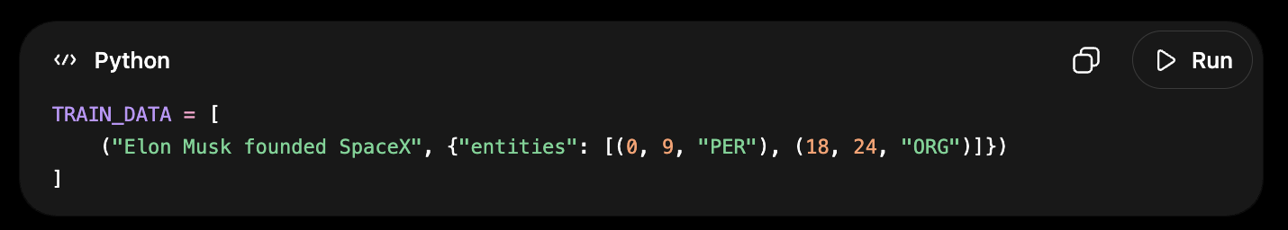

Task 5 — Dataset Engineering Challenge

Objective: Create a clean dataset pipeline:
- Shuffle dataset
- Split into:
  - Train (70%)
  - Validation (15%)
  - Test (15%)

